**Creating a simple Stream Analytics job**

Create a new resource, click +New:

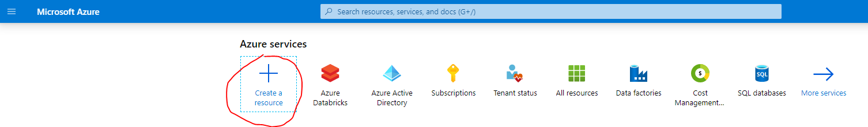

Click Stream Analytics:

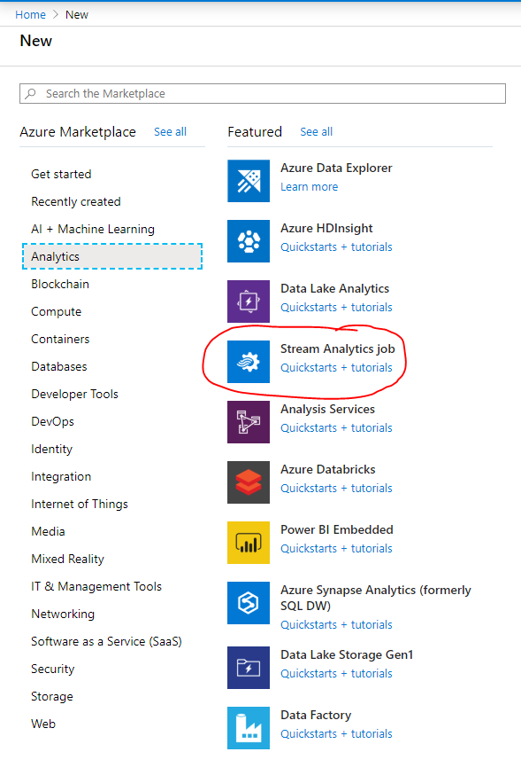

Configure the details of the Stream Analytics job:

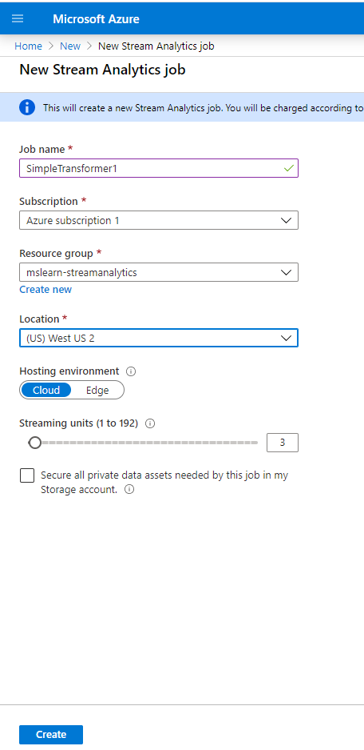

The job will be deployed:

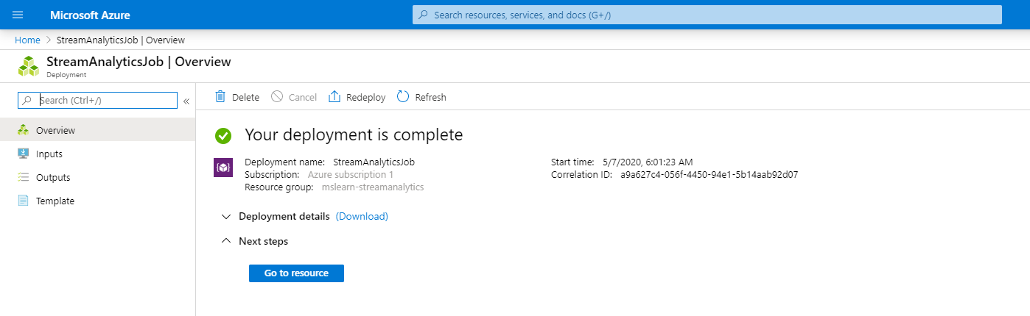

Click on the Inputs area to configure the input:

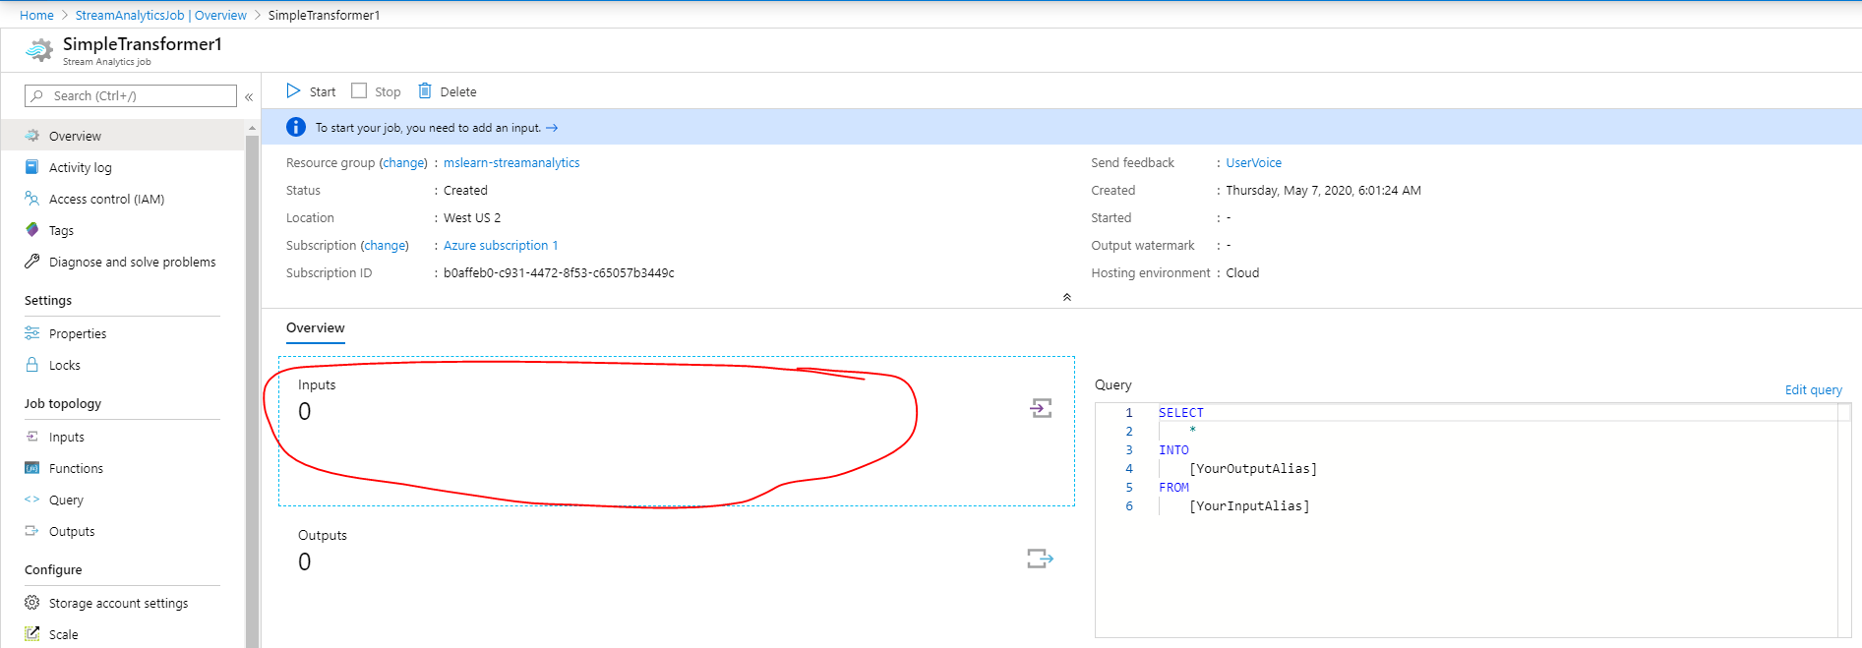

On the inputs tab, click Add Stream Input and select Blob Storage:

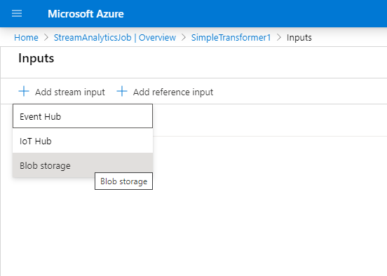

Fill in details of the input data source (Blob):

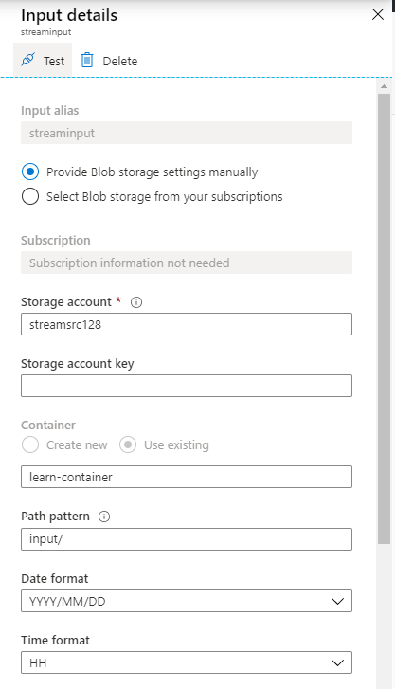

Click on the outputs section to configure the output:

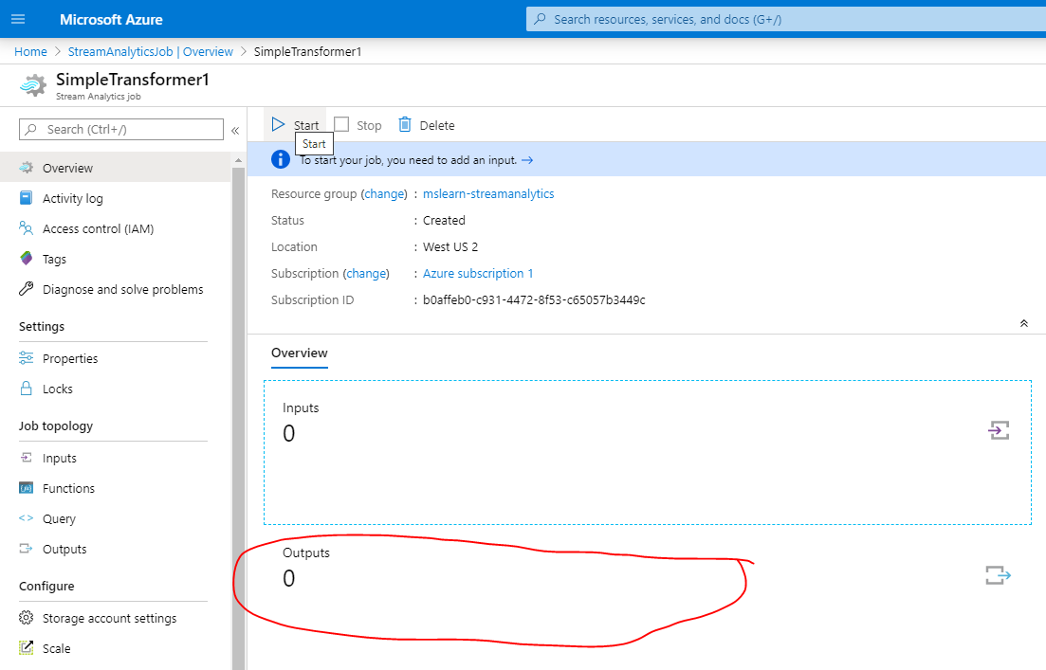

On the output tab, click +Add and select ‘Blob Storage’:

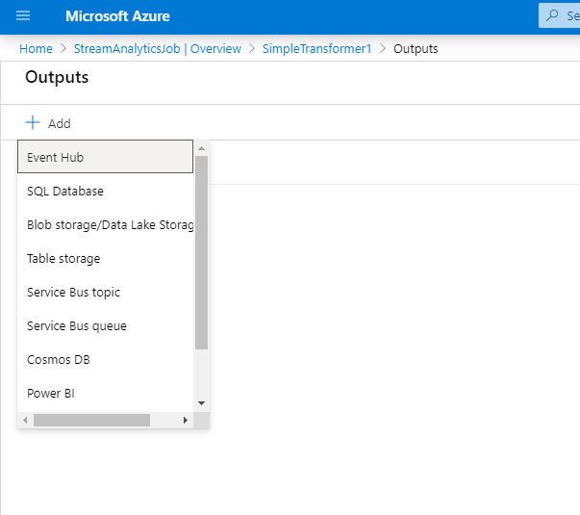

Configure the details of the Output stream:

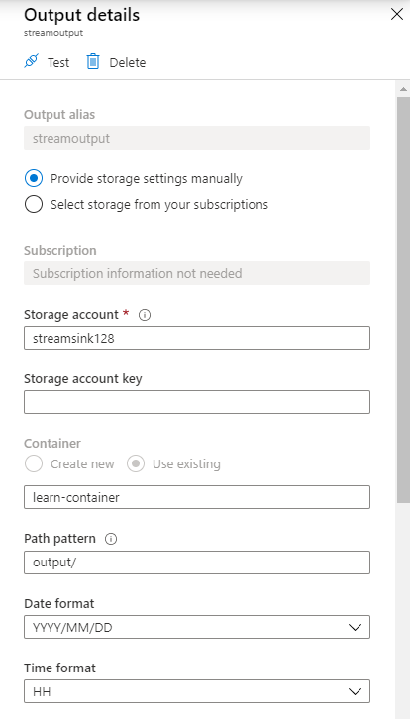

Next edit the query:

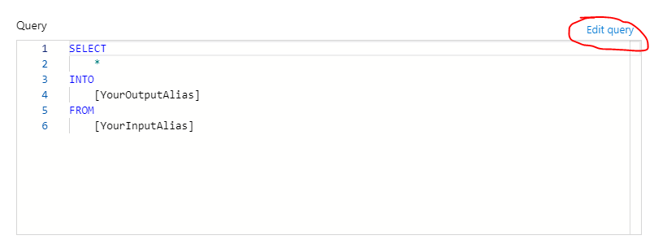

Configure the query to stream data from the input source to the output source:

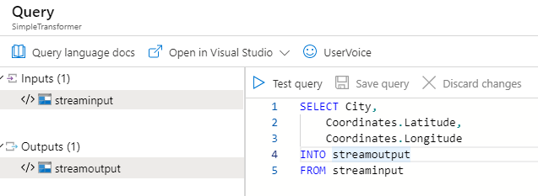

Once complete, Test the query.

Click Start to initiate the Stream Analytics job:

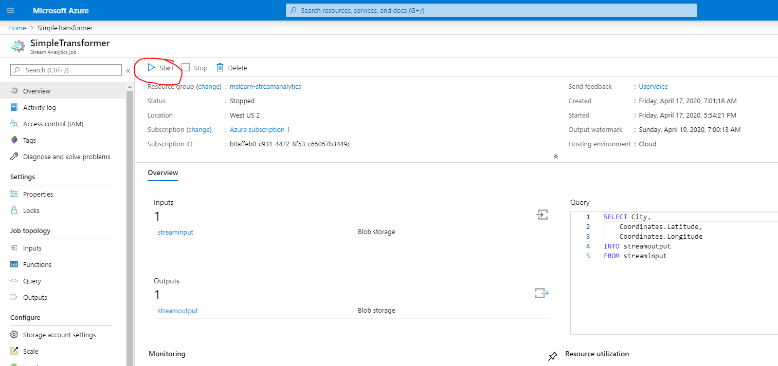

Start the job now:

